Bereshit

When God began
began to create

unformed and void
separated

Let there be
Let the

water

earth 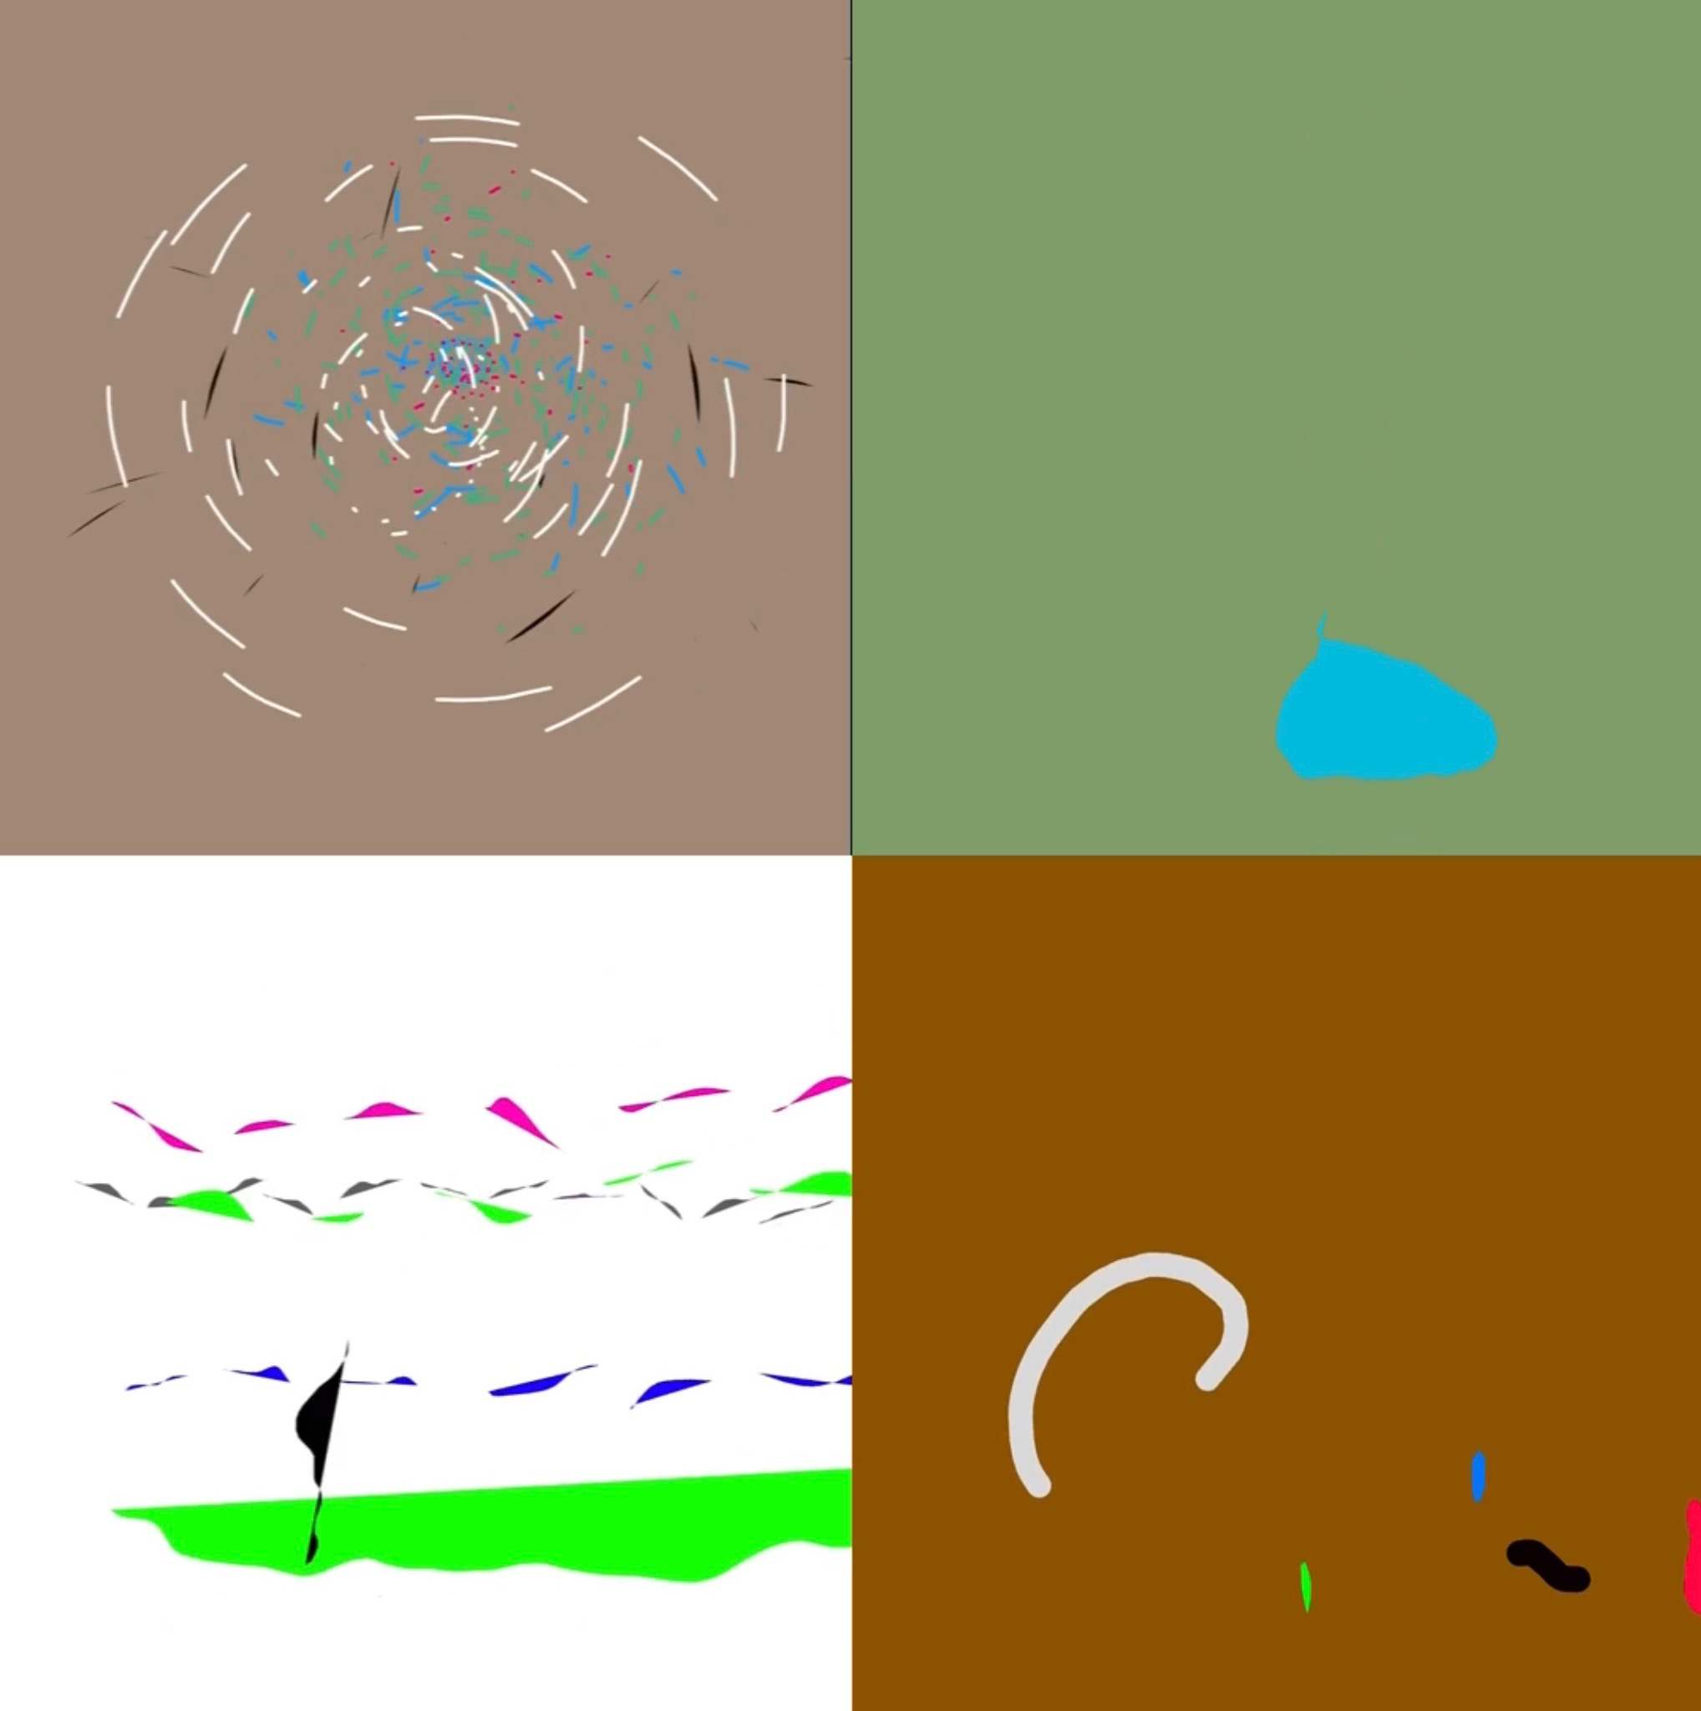

lights

See, I give you every

And to all
and to everything

the breath of life

And it was so.

