Saturday, Oct 31, 2020. לח לח

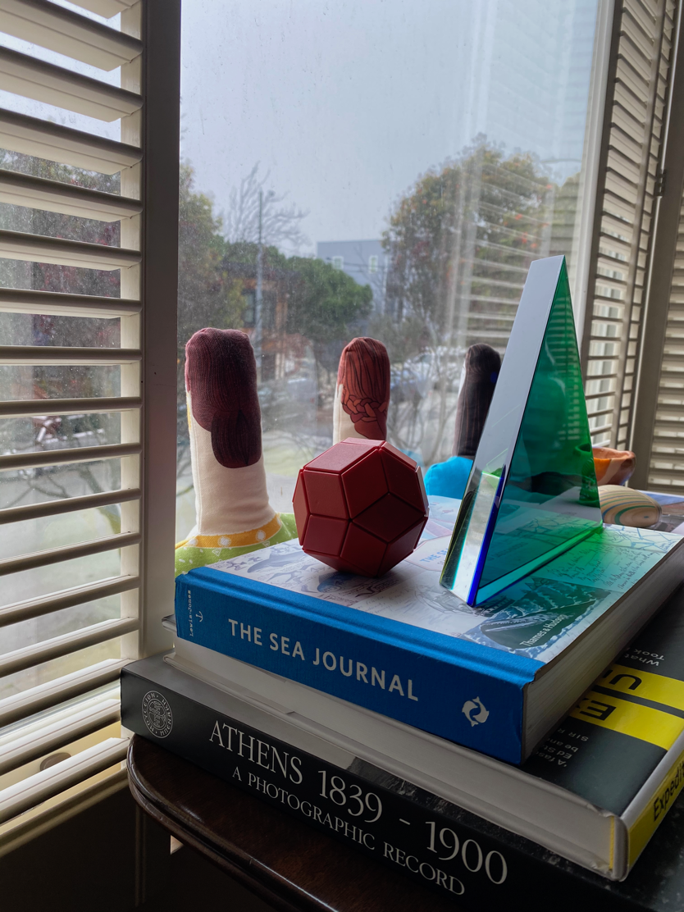

*

a few possible translations of lech lecha:

go forth
go inward
go to the root of yourself
go to the unknown part of yourself
go to your potential self

*

je est un autre
I is an other
Arthur Rimbaud

*

Abram threw himself on his face; and God spoke to him further. LL

*

The children of the covenant follow sound, not sight, the voice of God in the depths of the soul, not the seductive surfces of the visible.
Rabbi Jonathan Sacks, Covenant and Conversation

*

Anthrology is less the study of culture as an object of understanding, than the culture of cultivation of humanity as a method of change.
Anand Pandian, A Possible Anthropology: Methods for Uneasy Times

*

Nature has formed man most of all living creatures for participating in the fate of others.
Johann Gottfried Herder, Outlines of a Philosophy of the History of Man

*

It cost a euro to use the toilet at the border.
Suketu Mehta

*

I will make your offspring as the dust of the earth...
LL

*

(There's often been a troubling alliance between extreme environmentalists, the zero-population growth crowd, and racists, based on a common fear of density.)
Suketu Mehta

*

And all the families of the earth/Shall bless themselves by you. LL

*

There wasn't enough time to develop trust, but everyone likes a listener.
Claudia Rankine, Just Us: An American Conversation

