Vayera

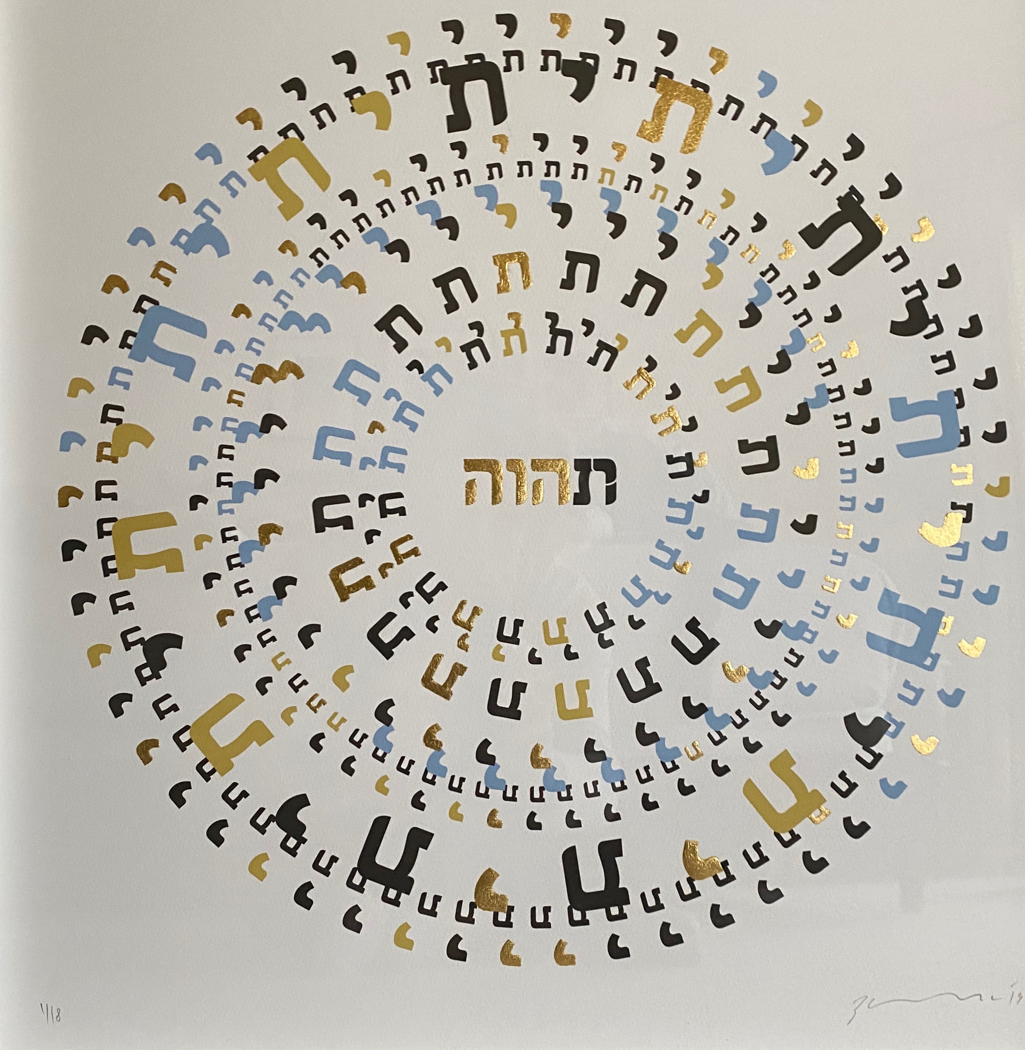

The Lord appeared
as the day grew hot

Three men

he ran
to greet them and,
bowing to the ground

water
bathe
recline

a morsel of bread

Quick, three seahs…!
knead and make cakes!

He waited on them under the tree as they ate.

*

I did not laugh
you did

*

Lot's wife looked back

*

saddled his ass and took with him...and his son Isaac

took the wood…

Father!

built an altar
laid out the wood
bound his son
laid him on
picked up the knife

Here I am.

